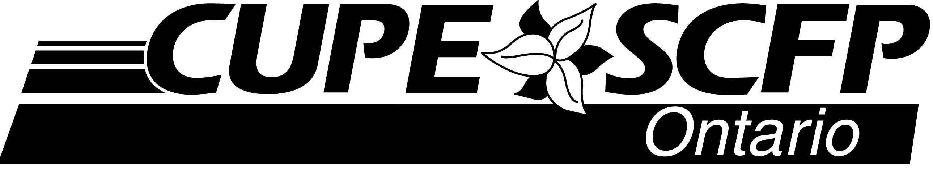
80 Commerce Valley Drive East, Suite 1
Markham, ON L3T 0B2
Phone: 905-739-9739 • Fax: 905-739-9740
Web: cupe.on.ca E-mail: info@cupe.on.ca

FOR IMMEDIATE RELEASE MEDIA RELEASE June 29, 2017
MEDIA RELEASE
CUPE Ontario congratulates parents and education workers for victory in stopping school closures
TORONTO, ON (June 29, 2017) – Parents, education workers and community supporters should be very proud of their success in getting the provincial government to put an end to school closures in Ontario, says CUPE Ontario President Fred Hahn.
“These families and workers never gave up,” said Hahn. “They knew how valuable their local schools were to their communities and they refused to let the government take them away. They are an inspiration in what can happen when you come together and refuse to take no for an answer.”
“Closing local schools is not just bad for the students,” said Terri Preston, coordinator of CUPE Ontario’s School Board Bargaining Committee. “Local schools are at the heart of most communities. They’re the place where people gather to play sports, hold community meetings and engage meaningfully with each other. Today’s announcement is good news.”
The Ontario Liberal government has taken a lot of heat over the past several years for ignoring the needs and voices of local communities by steam rolling ahead with school closures that have left huge holes in some rural communities.
“Given the government has now seen their mistake, we hope they will reconsider the closures that they have already announced,” said Preston. “There are communities that are really struggling with the loss of their school – this still needs to be addressed.”
“We’re pleased the government has finally come to its senses and put in place a moratorium on school closures,” said Hahn. “We just hope that it continues past the next election.”

-30-

For more information, contact: Sarah Jordison, CUPE Communications, 416-578-5638
www.cupe.on.ca

